REACT ASSIGNMENT PROPOSAL DOCUMENT

THE PROJECT SCORE

This project will take about two weeks to fully implement.

LIST OF FUNCTIONALITIES

1. At first the index page has a random mathematical numbers between one and nine which a user will have to solve to access the dashboard where they can interact with the data from the API. The index page also has proper error handling techniques which enables the user assess whether they are wrong or right.
2. In the dashboard a user will have to enter a city or country and hit enter where the backend code will call the API and throw the weather data for that specific location.

WIREFRAMES PICTURES.

**Index**

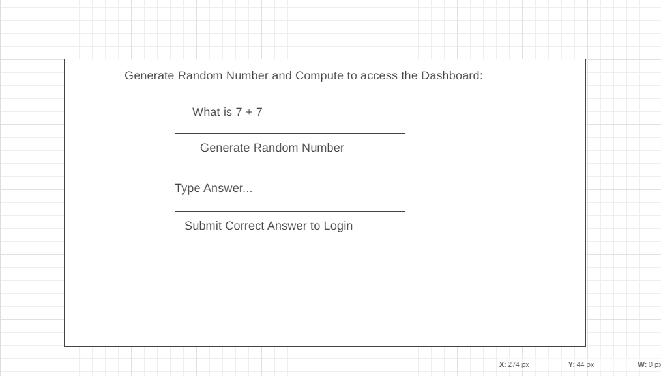

**Dashboard**

